HATTON TECHNOLOGY PARK
HATTON WARWICK CV35 8XB
(formerly known as Nunhold Business Centre)

TO LET
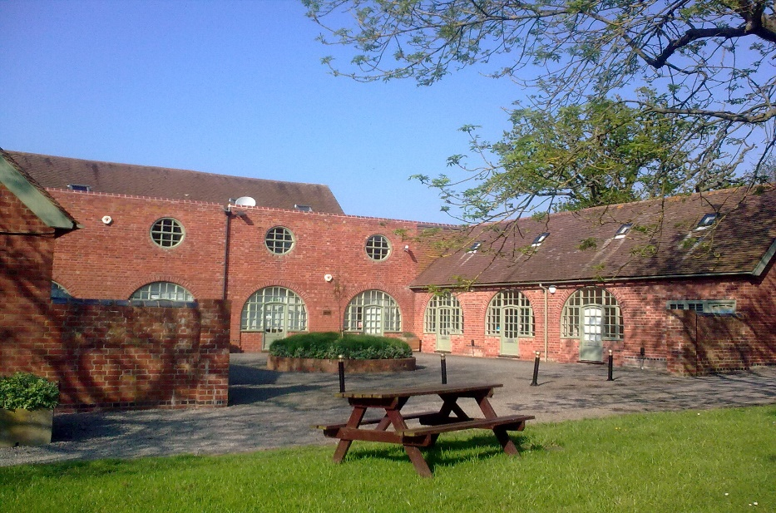

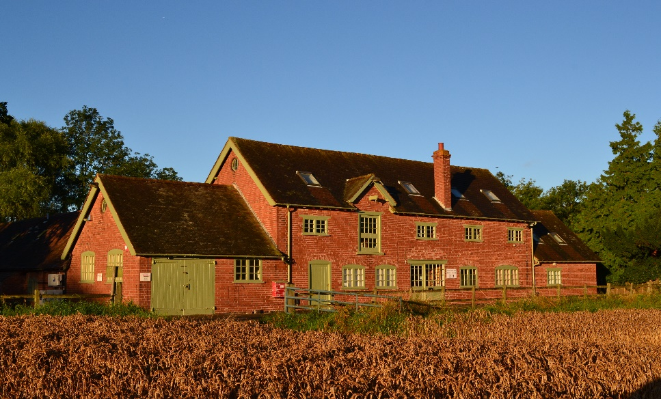

COMPETITIVE TERMS – UNCONTENDED HIGH SPEED INTERNET
SELF- CONTAINED CHARACTER OFFICE PREMISES
From 400 sqft – 4,000 sqft
(37 sqm – 371 sqm)
AMPLE FREE PARKING - M 40 (J.15) 10 mins
Birmingham – Warwick - London Railway Line 5 mins drive
www.hattontechnologypark.co.uk

Description

Hatton Technology Park has installed the latest generation of high speed internet to become the first rural Technology Park in the south Midlands to offer this crucial service.

The Technology Park is owned by Johnnie Arkwright whose Ancestor Sir Richard Arkwright made the technological breakthrough with the Spinning Jenny that led to his building the first factory in the world in 1770. It was the start of the Industrial Revolution and the end of cottage industry.

Now Mr Arkwright is reversing the process by using the very latest technology to enable businesses to return to the countryside. He said in an interview with Birmingham Post Business - “The lack of high speed internet access in rural areas is a big national issue. We are making a significant investment and the response from prospective occupiers has been fantastic, it’s a real breakthrough”.

Location

Companies like the location as it allows easy access to the Motorway and Railway networks. The M40 (J.15) is within a 10 minute drive, Birmingham is only 15 miles, Birmingham International Airport, 10 miles and the high speed Railway connection at Warwick Parkway (5 mins) Birmingham – London line.

Hatton Technology Park (CV35 8XB) is located off the A.4177 Solihull to Warwick road.

Current Availability:-

Unit 1 & 2 The Courtyard @ Hatton Technology Park
1700 sqft (157.93 sqm) ground and first floor offices – see first photo front page
£22,100 per annum plus VAT

Unit 3 The Courtyard @ Hatton Technology Park
1453 sqft at ground and first floor level – see first photo front page
£20,000 per annum plus VAT

Unit 8a @ Hatton Technology Park
450 sqft ground floor OFFICE first floor LET
£6,750.00 per annum plus VAT (see second photo front page brochure)

Rates:-
The business rates (approx below) are payable to Warwick District Council. You may be eligible for small business relief which will reduce these charges significantly. Full rates relief could be available if the RV is 12k or under.

The Rateable Value is not the amount you will pay. The RV is used to calculate your rates bill.

Service Charge
There is a service charge at Hatton Technology Park covering the cost of building repairs, buildings insurance, maintenance of communal areas, rubbish collection, postal collection, landscaped areas, together with communal lighting, car parks and driveways. The service charge is plus VAT and to the year ending September 2021.

Unit 1 & 2 £3,400.00 pa
Unit 3 £2906.00 pa

Information
There will be a flat fee for preparation of the legal Agreements.

The ingoing tenant will be required to pay the equivalent of 3 months rent to be held in as a holding deposit with the rent to be paid quarterly in advance at the commencement of the term.
Mains water and electricity is available. There is no mains gas. High Speed uncontended internet connectivity is available (100 MB bearer speed) with each tenant choosing from a number of services including managed band-width, telephone solutions and on-line back-up. Further information and costs are available upon request.
VAT is charged on rent and outgoings.

The premises are available to let on new Lease, subject to a minimum term of 3 years.

Other Lettings at Hatton Estate

Elsewhere on Hatton Estate, we have availability including retail and office premises at Hatton Country World, small storage facilities at Little Nunhold (1 mile from Hatton Technology Park) and light industrial storage (1500 sqft plus) at Ivy House, Hockley Heath (approx 15 minutes drive from Hatton Technology Park).

Retail Shops at Hatton Country World from 300 sqft to 3,000 sqft

6 & 7 Little Nunhold. Each approx 200 sqft workshop/storage. Rent: £1,500 pa per unit. NOW LET

Storage/Warehousing at Hockley Heath, 2,700 sqft – LET

Viewing: Please contact Caroline Clifton, Property Manager at Hatton Estate on 01926 844326 (direct dial), 078333 43503 (mobile) or email: cclifton@hattonworld.com

HEAD OFFICE: HATTON ESTATE, WARWICK, CV35 7LD
Telephone: Switchboard 01926 843411
email: cclifton@hattonworld.com
www.hattontechnologypark.co.uk

E-mail:cclifton@hattonworld.com tel: 01926 844326

Hatton Estate give notice that these particulars do not constitute any part of a contract or offer and are produced in good faith and set out as a general guide only. Hatton Estate does not make or give authority to make or give any representation or warranty whatsoever in relation to this property.

